
Department | FED
Subject | DSA-2
Academic Year
Faculty Name | G. Mamatha
Student Name | K. Hemanth
Roll Number | 2520030230
Branch | CSE
Course Outcome

Case Study Topic: Wikipedia hyperlink graph
Work Done Summary:
In this case study, we implemented Kruskal’s algorithm to determine the Minimum Spanning Tree (MST) for connecting railway stations with minimum electrification cost. The system consists of 6 stations and 8 possible links with associated costs. The requirement was to connect all stations such that the total cost is minimized and no cycles are formed.
We observed that Kruskal’s algorithm works by sorting all edges in ascending order of weight and then greedily selecting edges that do not form a cycle. The Union-Find (Disjoint Set) data structure was used to efficiently detect cycles. This approach ensures that the final network connects all stations with the least possible cost.
.Implementation Details:
- • Represented stations as nodes and links as edges
- Stored edges with weights in a list
- Sorted all edges in ascending order
- Used Disjoint Set (Union-Find) for cycle detection
- Iteratively added edges that do not form cycles
- Constructed MST with (V-1) edges

Result / Output:
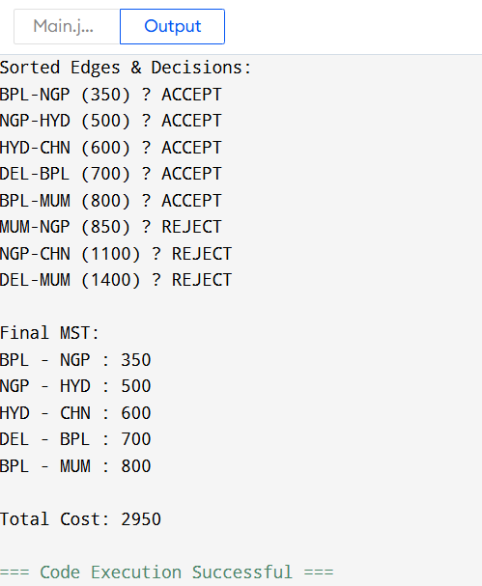
• BST is not suitable for real-time systems with sorted input
• AVL Tree is highly efficient due to self-balancing
• AVL ensures:
- Faster retrieval
- Reduced search time
- Better scalability

Time Complexity:
- Insertion: O (log n)
- Deletion: O (log n)
- Search: O (log n)

GitHub Link: https://github.com/hemanthkasani25-web

